20MCA136 – NETWORKING & SYSTEM ADMINISTRATION LAB Dept. of Computer Applications

|  |
| --- |
| **Name: VYSHNAV SURESH**  **Roll No: 56**  **Batch: B**  **Date: 05-05-2022** |

**NETWORKING & SYSTEM ADMINISTRATION LAB**

**Experiment No.: 12**

**Aim**

Write a shell script to check whether a given number is odd or even

# Program

echo -n "Enter number :" read n rem=$(( $n % 2 )) if [ $rem -eq 0] then echo "$n is even number" else echo "$n is odd number" fi

# Output Screenshot

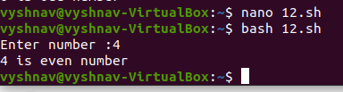

Amal Jyothi College of Engineering, Kanjirappally